Cawthorne NDP Issues and Options
Public Consultation - November 2017
Comments Form
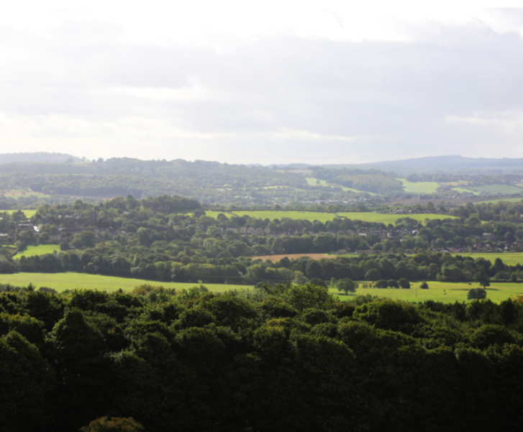
Cawthorne Parish Council is preparing a Neighbourhood Development Plan (NDP) to help guide decisions on planning applications in the Parish over the next 15 years.
We would like to know your thoughts about the planning issues we have identified so far, and possible options for addressing them.
An Issues and Options document has been prepared by the NDP Steering Group of Parish Councillors and local residents. Please find the full document on the NDP page on the Parish Council's website http://www.cawthorne.org.uk/ .
Please complete this form or provide any other comments in writing and return to:
Email address: abtechgroup@aol.com or deliver by hand to: The Post Office by 15th December 2017.
Questions
Draft Vision and Objectives

(Please Tick )

VO1. Do you agree with the Draft Vision and Objectives?
Yes
No

VO2. Please provide any comments suggesting how they could be improved.

Landscape, Wildlife and Environment Policy Options

L1. Should our NDP include policies to protect the local landscape character of Cawthorne? This would include, say, protecting locally important views, incorporating traditional boundary features such as dry stone walls, hedgerows etc and making sure new development (including renewable energy schemes) integrates well with its surroundings.

Yes
No

L2. Should the NDP include a policy encouraging development to incorporate features to support wildlife?

Yes
No

L3. Are there any other environmental issues which are NDP should address? Please explain your answer.

Community and Sports Facilities Policy Options

CF1. Should the NDP include a policy identifying local community facilities and supporting investment to improve them?

Yes
No

CF2. Should the NDP include a policy which identifies one or more areas of Local Green Space for protection from development?

Yes
No

If so, please identify them and explain why they are important.

CF3. Should the NDP include a policy encouraging new development to link to existing footpath / cycle networks and have suitable vehicular access to adoptable road standard?

Yes
No

CF4. Should the NDP include any complimentary actions for the Parish Council linked to improving local accessibility eg improvements in signage, improvements to footpaths etc?

Yes
No

If so, what would sort of actions would you like to see?

Housing Policy Options

H1. What sort of housing do you think is needed in Cawthorne? For instance, small, starter homes, affordable housing, housing for older people / sheltered housing, self-build schemes etc?

H2. Should the NDP identify site allocations for small housing sites within the development boundary?

Yes
No

Or

H3. Should the NDP just include a criteria-based policy (such as the one in the NDP) for new housing development that may come forward?

Yes
No

Design Policy Options

D1. What do you think are the significant local characteristics of buildings in Cawthorne?

D2. Would you support more modern / contemporary designs eg sustainable / low carbon buildings?

Yes
No

D3. Can you suggest any locally important buildings or features of special interest that should be protected in a Local List?

If so, please explain why they are important.

Tourism and Business Policy Options

TB1. Should the NDP include policies supporting appropriate local economic growth, taking into account the Parish’s location in the Green Belt and impacts on local character and amenity?

Yes
No

TB2. Should the NDP include a policy supporting tourism related economic development in the area?

Yes
No

Infrastructure Policy Options and Actions

INF1. Do you agree that the transport issues identified in paragraphs 9.4.1 to 9.4.3 are the key ones facing the village over the plan period?

Yes
No

If not, what else should the Plan address?

INF2. The way in which a package of traffic calming, speed restrictions and limited additional parking could support the Plan's vision is in the NDP.
Which of these elements are you in favour of? (please tick ):-

Disagree | Agree | Undecided
Slowing traffic to 20mph
Through the village

Reducing the speed limit on
Disagree | Agree | Undecided
the Bypass

Changing road layouts
Disagree | Agree | Undecided
And traffic calming

Introduction of yellow lines
Disagree | Agree | Undecided

Introduction of
Disagree | Agree | Undecided
Residents Parking Schemes

Investigating the feasibility
Of a new link road between
Disagree | Agree | Undecided
A635 and Cawthorne Lane to
the east of the village

INF3. Would you support restrictions on on-street parking in the adjacent area if necessary?

Yes
No

INF4. Should the NDP include policies requiring development to support other infrastructure investment eg flooding, new communications technologies and water / sewerage etc?

Yes
No

Please explain your answer.

Other Matters

GEN1. Are there any other planning issues which you think the Cawthorne NDP should address?

Thank you for your time and interest.
Your responses will be considered carefully and used to form our next document - the Draft NDP for Cawthorne.

