DRAFT Supplementary Planning Document

CAWTHORNE VILLAGE DESIGN STATEMENT

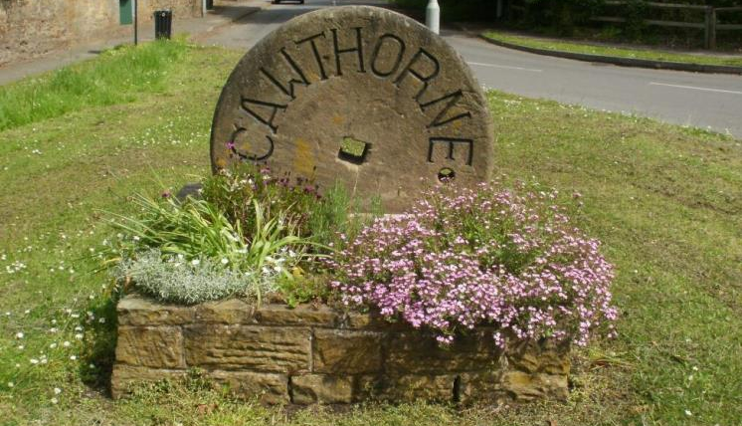

This guidance has been prepared by the Village Design Group supported by Cawthorne Parish Council, and updated in partnership with the Barnsley MBC. The Parish Council asked BMBC to adopt the design statement as supplementary guidance which supports the Local Plan (Adopted January 2019) and will be used to help make decisions on planning applications in Cawthorne.
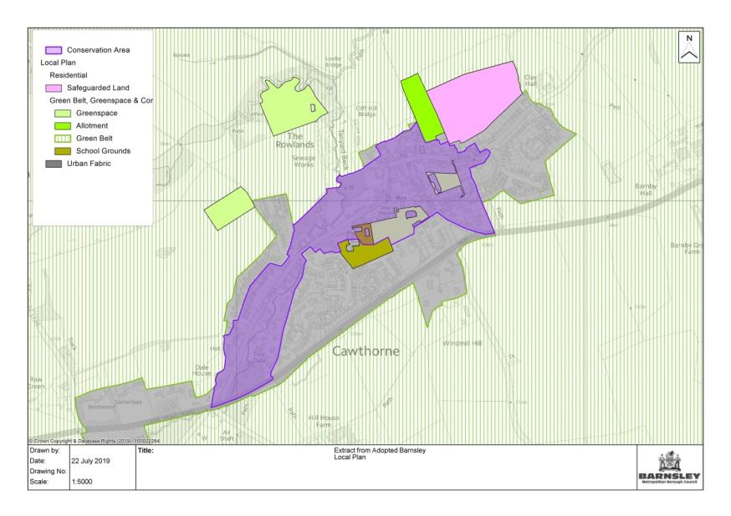

A Statement from the Design Group

Many of us take for granted our lovely old village with its strong sense of identity. We would be wrong, however, to assume that life in Cawthorne will continue unchanged. Villages and communities constantly evolve as does their way of life. For a village of some 1300 or so residents the community is very fortunate to have a well-attended Parish Church and Methodist Chapel, a successful Junior and Infant School, a Pub, a Post Office, two Clubs, a Restaurant, Village Shops and the award winning Victorian Jubilee Museum. Many of these facilities are supported by a host of voluntary village organisations which cater for a wide range of leisure activities for all age groups. This rich pattern of village life will not automatically continue forever and we should all work to ensure our village retains what is left of our traditional rural way of life.

The village design statement briefly describes Cawthorne as it is today and highlights the qualities valued by residents. The statement has been written by Cawthorne residents with input from BMBC so that local knowledge, views and ideas may contribute to the growth and prosperity of the village, and to a high quality environment. The aim is to ensure that further development and change is based on a considered understanding of the village, including its past and present. As such it is intended that change will be carefully managed in order to protect and enhance what is special and will contribute positively to the future of Cawthorne. The statement is not a set of rigid rules but is intended to be a collection of sensible criteria to encourage good design.

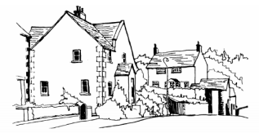

About this guidance
The National Planning Policy Framework (NPPF) indicates that Local Development Documents form the framework for making decisions on applications for planning permission. Decisions have to be taken in accordance with the development plan unless other material considerations indicate otherwise. The NPPF advises that a local planning authority may prepare Supplementary Planning Documents to provide greater detail on the policies in its Local Plan. Supplementary Planning Documents are a ‘material’ consideration when planning applications are decided.
As required by the Planning and Compulsory Purchase Act 2004 we have prepared a Statement of Community Involvement (SCI) which sets out how we will involve the community in preparing our Local Plan and consulting on planning applications. In accordance with the SCI we have involved people who may be interested in this Supplementary Planning Document and asked them for their comments. We have produced a consultation statement which summarises all the comments people made to us and our response. This is available on request.
Introduction
This document offers guidance to residents, landowners, architects, agents and builders on both new development and smaller day-to-day adjustments to homes and gardens, open spaces, paths and hedges which can alter the look and feel of the whole village. The Statement provides guidance to those proposing development in Cawthorne.
Policy
This document supplements Local Plan policy D1 which states:
Development is expected to be of high quality design and will be expected to respect, take advantage of and reinforce the distinctive, local character and features of Barnsley, including:
- Landscape character, topography, green infrastructure assets, important habitats, woodlands and other natural features;
- Views and vistas to key buildings, landmarks, skylines and gateways; and
- Heritage and townscape character including the scale, layout, building styles and materials of the built form in the locality.
And,
Through its layout and design development should:
- Complement and enhance the character and setting of distinctive places, including Barnsley Town Centre, Penistone, rural villages and Conservation Areas;

This document also supplements Local Plan policy HE1 which states:
We will positively encourage developments which will help in the management, conservation, understanding and enjoyment of Barnsley’s historic environment, especially for those assets which are at risk by:-
a. Supporting proposals which conserve and enhance the significance and setting of the borough’s heritage assets, paying particular attention to those elements which contribute most to the borough’s distinctive character and sense of place.
These elements and assets include:-
- 18 designated conservation areas of special and architectural interest including three town centre conservation areas, as well as large areas incorporating Stainborough Park, Cawthorne, Penistone and Thurlstone.

- A number of important 18th and 19th century designed landscapes and parks including Wentworth Castle parkland (the only grade I Registered Park and Garden in South Yorkshire), and Cannon Hall Park.

OLD CAWTHORNE

When the Domesday survey was carried out in 1086 it records “in calthorne there is a priest and
A church”. The present parish church of All Saints’, like its predecessors on the same site, dominates the village and continues a tradition of service to the community which has lasted unbroken through all weathers and crises since before the Norman Conquest.

Two of the earlier village buildings from the 15th century are still in use. One is part of the house known as Golden Cross at the centre of the village and the other is a building at Barnby Hall, now a farm workshop. Early buildings were all timber framed with thatched roofs and wattle and daub walling. During the latter part of the 17th century these old houses began to be clad in stone-work and roofed in Yorkshire stone slates.

Originally, the core of the village developed to the north of the Parish Church at the top of the hill, and then spread westwards along Tivy Dale and eastwards down Darton Road. In the early days of the village there were more outlying cottages and communities which grew in the late 18th and 19th centuries with the growth of the coal industry.

Residential development in the 1920’s and 30’s and since the Second World War further extended the village settlement along Darton Road and Kirkfield Close. Subsequently, development extended to Stanhope Avenue, Orchard Terrace, The Park, Tivydale Drive; and, most recently the St. Julien development. Despite the lateral growth of the village, the population of Cawthorne is at a similar level to what it was in 1840; due to the loss of the outlying cottages and communities and the substantial reduction in the labour force in agriculture.

Design Guidelines

Building Materials and Prevalent Styles of Architecture

Stone and Brick

Historically, the stone used in the buildings of Cawthorne was locally quarried sandstone. This stone is generally not a course gritstone, but is a finer grey sandstone (often referred to as Delph) with orange veins caused by the presence of iron. Some of the old houses and particularly their outhouses were partially built of locally made red rustic brick and these have become an acceptable part of the village vernacular. Although stone is preferred for new build, this rustic brick can (if well matched) be an occasional complementary variation to the use of stone in the Conservation Area.

- Wherever stone remains in reasonable condition it should be retained.

Where stone has to be replaced or where new development is proposed coursed ‘Delph’ sandstone should be used. Coursing of 150mm and above should be avoided as should the use of the courser gritstone (typical of more upland areas) as this is not typical to the village.

Pointing

This should be flush or rounded off by brushing or “bagging off” to a gently concave joint. Prominent strap or ribbon (over) pointing which utilises hard (but brittle) cement should always be avoided. Lime pointing is always preferable when carrying out the re-pointing of historic buildings or walls*. A typical mix appropriate for this historic context includes:

- One part Naturally Hydraulic Lime (NHL 3.5) gauged with 3 parts well graded (mixed) aggregate.

* Further guidance on this can be found within the Mortar Mixes for Historic Buildings Supplementary Planning Document.

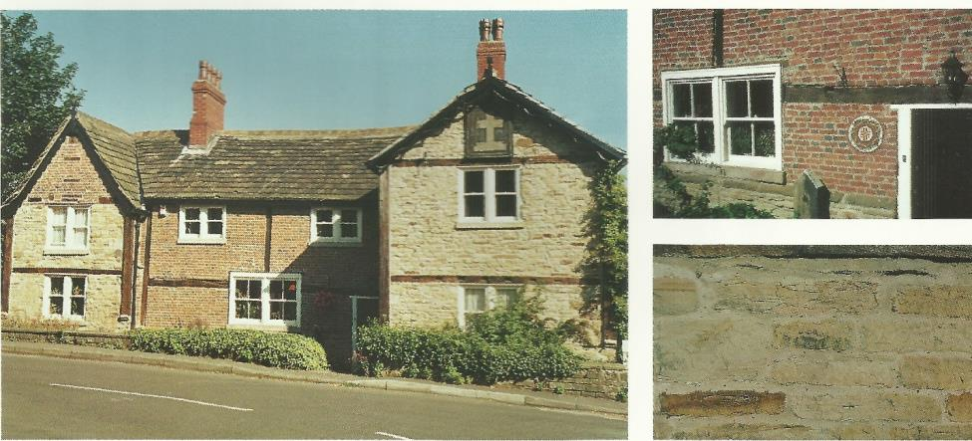
Roofs

Roofs on older 17th century houses tend to be steeply pitched with tabling or good over-sail at the gable verges which give the roofs a strong appearance. This characteristic should be preserved. Coursing on roofs with stone slates generally diminish in size towards the ridge and normally have ridge tiles that match. From the early 18th century onwards these characteristics continued but with less steeply sloping roofs.

- Within the Conservation Area natural stone slates are the preferred roofing material. Good quality, matching artificial stone slates may be suitable given the availability and cost of natural stone slates. However, for listed buildings stone slates are preferable.

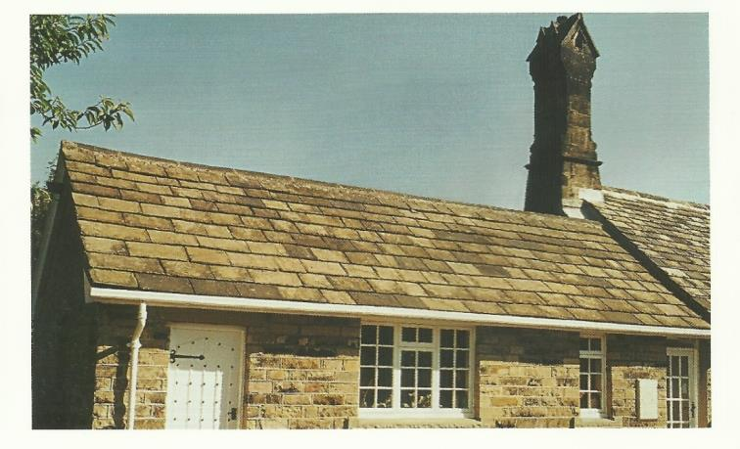

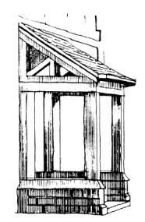
Porches

Porches on older houses tend to have exposed wooden framework on a stone base or occasionally on pad stones or stylobates.

- This is a village characteristic that should be preserved.

When porches are retrofitted or added as part of a new development the pitch of the porch roof should be similar to that of the roof on the house.

Chimneys

Chimneys are often an important feature of traditional houses and there are many attractive chimneys in Cawthorne, particularly around the historic core of the village.

- Some chimneys are built in stone and these should be maintained and renewed in like for like materials.

A characteristic of some chimneys in Cawthorne is the chimney stack built in bricks of two shades, with rustic red brick and buff-coloured brick. Oversailing chimneys (where the stack increases in circumference towards the top) are common and are often characterised by corbelled brickwork. Some chimney stacks have been rebuilt in common red brick and may be cement-rendered. These tend to look out of character and should be re-instated as above when the opportunity arises.

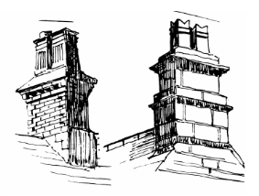

Windows

Windows and their design are one of the most influential features within an elevation and careful thought should be given to their appearance. Replacement windows should (whenever possible) reflect and sympathise with the appearance of the host building and should be consistent in terms of character and style. Many of older houses have stone jambs, heads and sills.

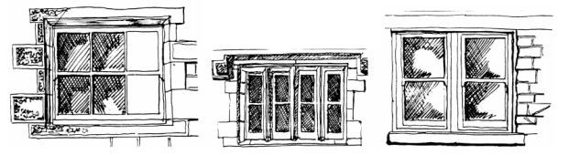

17th century houses tend to have stone mullions (vertical dividers) within the windows and these should be retained or if beyond repair replicated. This is particularly relevant when dealing with listed buildings or historic buildings within the Conservation Area.

- These features give houses substantial character and should be retained and encouraged in any new build or rebuild.

Doors

Traditionally these were ledged, framed and battened and often braced. This is still a favoured design but often additional light is required and glazing is introduced. Fifteen light doors and Victorian panelled doors can often look appropriate, but doors should reflect the age and character of the property or be in balance with the architectural form.

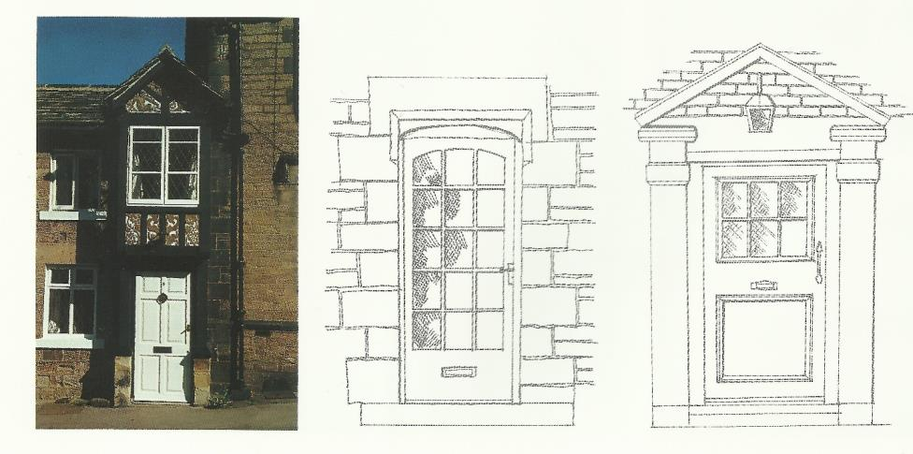

Kirkfield Close

Kirkfield Close was built in 1936; this small development of Art Deco semi-detached houses is perhaps one of the finest examples of this style of architecture in the area. Although not strictly in character with Cawthorne it has matured, retained its individuality, and developed a charm of its own thus contributing much to the village.

New Development

New development should endeavour to reflect the existing mix of properties. It should blend in and enhance the village being sympathetic in design layout and apearance. Existing views of the village, both looking out and into the village should be protected. Any infill development or lateral extensions to existing buildings should maintain significant gaps which provide views into and out of the village.

Highways and Footpaths

The building of the Cawthorne bypass in the early 1930’s has done much to protect the village from increased traffic. However, the present network of roads is under pressure. Car parking can be a problem and concerns remain over the excess speed of traffic through the village. We are fortunate that we still have a network of footpaths which criss-cross the village. With few exceptions these are in good repair. Footpaths in the Conservation Area have mainly stone curbs; these should be preserved whenever possible.

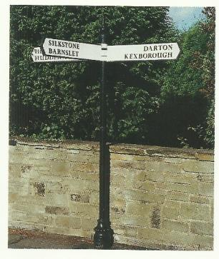
Street Furniture

Cawthorne has a number of attractive seats which have been donated and placed in strategic positions. Any future seats introduced should match the existing.
Street lamps and road signs have been installed over the years and consequently there is a mis-match of styles and materials.
Progressively, the road signs and street lamps should be replaced. The street lamps should be replaced with swan neck style in keeping with the Conservation Area. Litter bins of a high standard have been installed.

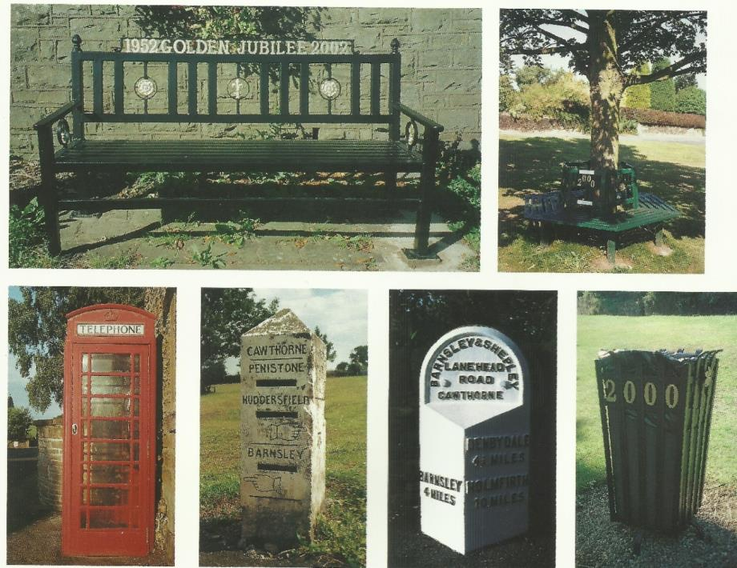
Open and Green Spaces

There are several “open green spaces” in the village and these should be retained and sensitively managed as per Local Plan Policy GS1.

Village Green

The village green is a large grass triangle of land at the entrance to the village. It is used by the village for events such as the Village Sing, Village Fête etc. and was formed when the Cawthorne bypass was built in the 1930’s.

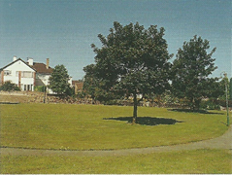

The Orchard

The Orchard situated at the back of the Spencer’s Arms is the remainder of an old orchard and is used as a play area for children. The orchard status is maintained by keeping the fruit trees (some ancient varieties) and replanting with new trees.

The Churchyard

The churchyard, an ancient burial ground, and the adjoining cemetery, provide tranquil areas. The cemetery is still in use.

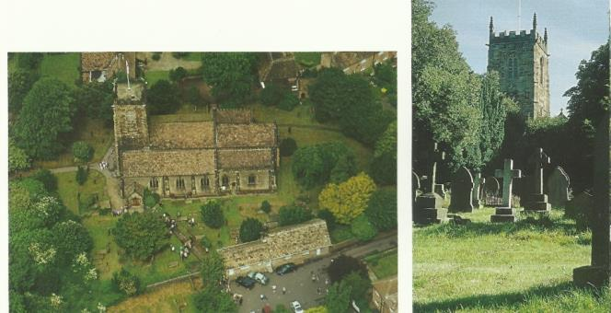

Rowlands Sports Area

The Rowlands sports area currently used by the cricket club, has been transferred from C.I.S.W.O. to the Parish Council. A recreation Ground Trust has been formed to manage and enhance these sports facilities.

- Careful planning must be adhered to in order to keep the character of the rural environment.

Local Economy

Cawthorne’s major industry of the past was agriculture, but also of importance was coal and iron. The Spencer family, who bought the Cannon Hall estate in the mid-17th century, had many interests in the local iron industry and owned Barnby Furnace. Coal was used extensively in iron smelting in the mid-18th century, and the opening of the Barnby Canal to Cawthorne Basin, in 1800, gave great impetus to the local collieries. Coal production probably reached its peak in Cawthorne shortly after this date. In the middle of the 20th century about 60% of the surrounding land was opencast for coal until the last site, at Barnby Furnace, was restored in the mid 1970’s. Today the village exhibits few reminders of its industrial past and often it is only in street place names that the earlier history can be detected.

Today, village shops, small businesses and the school provide everyday needs and help maintain community life. Tourism is increasing and the proximity of Cannon Hall and Country Park, together with the Open Farm, has greatly increased the number of visitors to the village (especially school trips). As such it is important to retain and develop Cawthorne’s character as a working village with a variety of employment.

- Commercial developments or conversions should be complementary to a residential village in a rural environment. Occupiers of commercial properties should maintain them in a condition appropriate to their locality

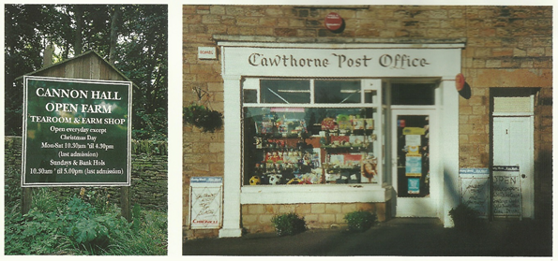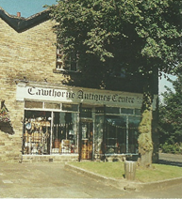

Shops and business premises can contribute much to the appearance and quality of a place such as Cawthorne. The look and feel of the village can be enhanced and preserved by using a sympathetic frontage in keeping with neighbouring buildings. Care should be taken to minimise the size of new or replacement shop front windows, branding, colours and signage.

- Please see Supplementary Planning Document - Shopfront Design, for further guidance.

Car parking in the village is relatively restricted. New developments or conversions to business use should provide parking facilities. Generally, designs, details and materials must be complementary to existing properties and respect established features in the landscape such as footpaths, trees, views etc.

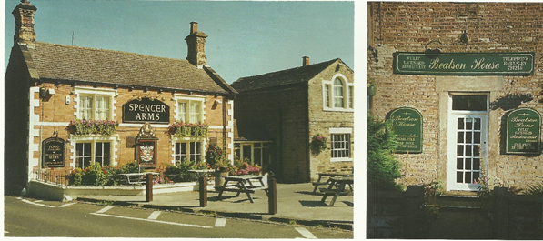

Farms

Cawthorne has some exceptionally fine, traditional farm houses dating from the 15th to the 19th century. Barnby Hall (15th century) and the Golden Cross (no longer a farm) are notable early examples. Many farms have fine stone built and rustic agricultural buildings of a similar age. Several houses and buildings are listed being of architectural and historical interest.

Many farmsteads have ceased to operate as agricultural operations and now form individual or groups of country houses (e.g. Thimble Hall, Pease Grove, Haddon South Lane, Woolgreaves, Waterslack, Lower Greaves and Upper Elmhirst, on South Lane alone). Where old farm buildings are no longer viable for agricultural use, proposals for conversion to other uses will be considered in light of Local Plan policies GB2 and GB3. Further guidance is also contained in Supplementary Planning Document - Barn Conversions.

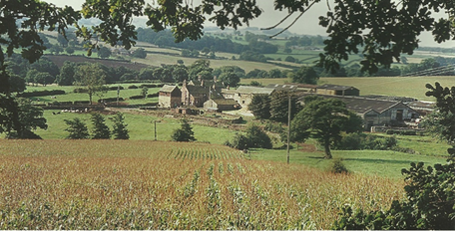

- Care must be taken to ensure that any new farm buildings blend into the countryside as much as possible and are landscaped with careful planting of appropriate trees. The uses of materials for agricultural buildings that are visually complementary to the rural landscape setting are encouraged. Dark brown or grey-green roofing, lighter brown or timber cladding and if possible stone coloured block work should be encouraged. White, blue or bright green sheeting, cladding or roof materials should be avoided.

Cannon Hall & Country Park

Cannon Hall and Country Park was sold to Barnsley County Borough Council in 1952. Cannon Hall, a Grade II* listed building (now a Museum) and the Country Park with its three lakes, beautiful old bridges and the Cascade waterfall, are known throughout Yorkshire. Cannon Hall Open Farm, Cannon Hall Museum and Cannon Hall garden Centre which are open most of the year, makes this park a very popular visiting place of many families. The park was originally designed by Richard Woods in 1761 for John Spencer and is now a Registered Park and Garden listed at grade II extending to 85 acres.

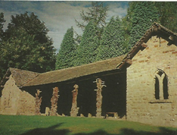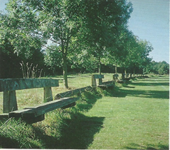
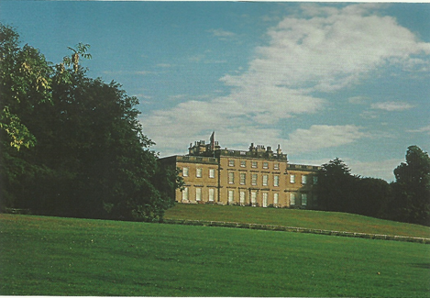

Landscape
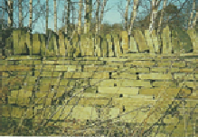
An important feature of the area is the network of dry stone walls and managed hedgerows.

- Maintenance of drystone walls and hedgerows should be encouraged and care taken to ensure these are not damaged due to new development.

Woodland

Cawthorne is surrounded by farms and woodland which combined with extensive tree planting in the parish allows the village to merge effectively into the surrounding landscape. The countryside has changed substantially over the past century due to open cast mining which began in 1943. Work is progressively underway to reinstate the natural landscape with extensive tree planting. The smaller pockets of woodland consist of broadleaf trees such as Oak, Sycamore and Ash and are in contrast to commercial woodlands which contain large plantings of conifer.

- New planting of trees and hedges should include native species to retain landscape character and benefit wildlife within the village.

- Views of Cannon Hall from the village should be protected.

- Leylandii and other quick growing conifers should be avoided.

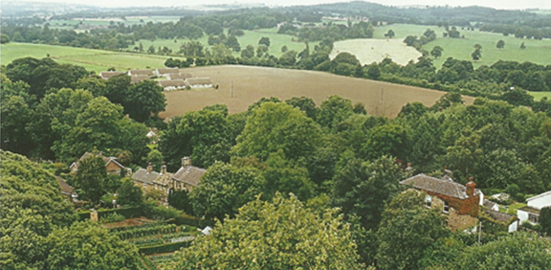

Biodiversity and Wildlife in Cawthorne

Cawthorne is rich in natural heritage assets and comprises a diverse mix of habitats for native flora and fauna.

- New development should avoid direct and indirect impacts on biodiversity. Landscaping schemes should incorporate locally prevalent species and provide areas of new habitat, such as grassland, deciduous woodland, wood pasture and parkland, ponds and water courses which benefit biodiversity.

Advice on wildlife issues is available from Barnsley Metropolitan Council contact number 01226 772606.

Allotments

The allotment gardens situated off Church Walk and on Taylor Hill provide useful extra garden space for residents, especially where properties have little or no garden land attached to the property.

- There should be a presumption against development on these allotment sites other than to provide improved access to other land.

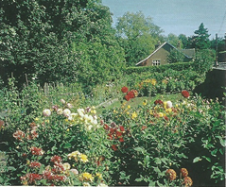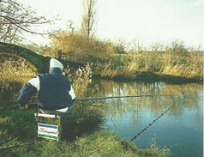

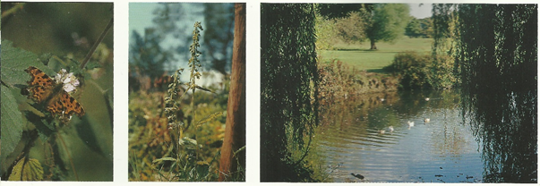

The Future

New developments and the many small changes that owners make to existing properties have the potential to alter the character of Cawthorne. Cawthorne’s charm lies in the fact that it still retains its traditional simplicity and restrained vernacular character. As such carefully considered and managed change that is harmonious and sympathetic to the character of the village is to be encouraged. Wherever possible, improvements and exterior alterations are to be kept simple, avoiding out of scale or complex urban embellishments which are generally not in keeping with the village.

Thank you for helping to conserve Cawthorne

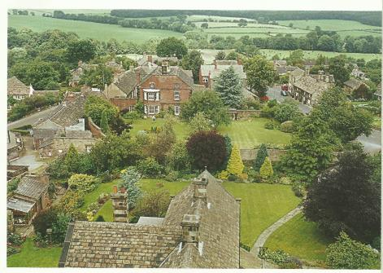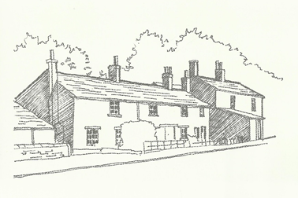

The Design Group

Kath Allass, Tony Allen, Diana Asquith, Robert Barr, Tony Butterworth, Gill Buckingham, Ron Carbutt, Terry Davis, Nicholas Farman, Lynda Jennings, John Lees, Frank Matthewman, Roger Nicholson, Emma Parenti, Trevor Watkins, Bernice Wright, Tony Wiles (BMBC)

